**Brief bio: Introduce yourself, including your academic background, major, and career goals.**

**Professional photo: A clear and professional looking photograph of yourself.**

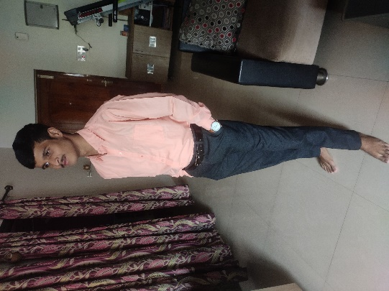Good morning, I am Subhapreet Patro, an engineering pursuing my B. Tech in Computer Science and Engineering at Malla Reddy University. My native place is Puri, Orissa, which is also known for its presence of one of the Chardham sites – the Jagannath temple. I completed my secondary education from Scholars International School, Puppalaguda and my Intermediate in Sri. Chaitanya Junior College, Narsingi. My hobbies include playing chess and video games, as well as listening to music. My goal is to become a skilled software engineer because computers and technology always surprise me. At present my aim is to upskill myself by enhancing my communication skills and technical skills.